NEW YORK CITYMCj03209700000[1]

HCC ALUMNI & FRIENDS

WOMEN ONLY BUS TRIP - SEPT. 26 – 28, 2014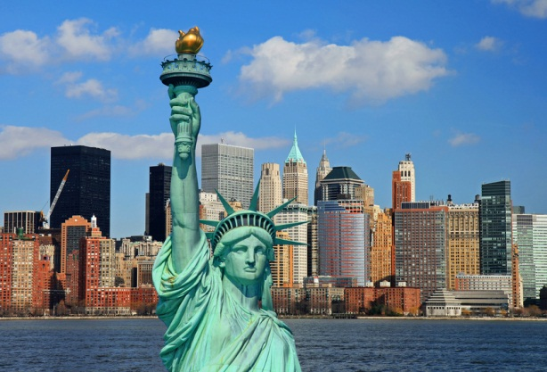

That’s right, SAVE THE DATE for the HCC Alumni Association’s Women’s Bus Trip to New York City. Grab three of your best friends (all rooms are quads), 18 and over, and plan on joining us for a weekend in Time Square. We will be staying at the Marriott Marquise Hotel for two nights. Start thinking about the plays you’d like to see, the fall tours that are available – Tiffany’s, Statue of Liberty, Little Italy, Chinatown, the Garment District, Central Park, the 9-11 Memorial, Battery Park, and SO MUCH MORE. There’s plenty of time to plan with friends all the great things to do, places to see, and restaurants to enjoy.

Trip includes: roundtrip transportation to New York City from HCC, two-nights, three-days at the Marriott Marquise Hotel at Time Square in NYC, driver tips, luggage handling, and all hotel taxes.

**HCC Alumni Association Members - $340.00 per person**

**All Others - $350.00 per person**

**Space limited, get your reservations and money in TODAY.**

- - - - - - - - - - - - - - - - - - Cut Here & Return W/Payment(s) to HCC Alumni Office - - - - - - - - - - - - - - - - - -

**Names of all attending: ______________________________________________________________________**

**Address: __________________________________________________________________________________**

**Phone: ___________________________________________ Cell: ___________________________________**

**E-Mail Address: ____________________________________________________________________________**

**Reserve your seat(s) with your payment in full!**



**Tickets will be sold on a first come first served basis. Seats are limited to 52 persons**

**So, tickets are limited.**

**Order TODAY!**

**Tickets are non-refundable, but may be transferred.**

NEW YORK CITY TRIP:

**# of Association Members Attending @ $340 each _____________________**

**# of Non-Association Members Attending @ $350 each _________________**

**Total Enclosed: $________________________________________________**

**Make check payable to: HCC Alumni Association & mail to: HCC Alumni Office, 11400 Robinwood Dr., Hagerstown, MD 21742**

**For more information, call the HCC Alumni Office at 240-500-2346, or e-mail** [**lsstewart@hagerstowncc.edu**](mailto:lsstewart@hagerstowncc.edu)